QQ 2020/21 Mystery Block of the Month- Step 3 The first triangle blocks!

Triangle Blocks

Now we are starting the fun stuff – triangle blocks!!

Each “big block” will have 2 different triangle blocks (as well as the 4-patch and the stand-alone 3.5” x 3.5” square that we made last month). The triangle blocks will be called AB1 and AB2 --- they will be mirror images of each other.

This month we will be making AB1 triangle blocks and next month we will be making AB2 triangle blocks. (Pro Tip: If you erroneously reverse any of the AB1 instructions, then put it aside for next month to use with AB2 - there are no errors, just future projects!)

IMPORTANT: Read this BEFORE YOU CUT YOUR STRIPS!

We are providing instructions for 2 different techniques for making the triangle blocks --- strip piecing and paper piecing. Pick your poison or try both techniques. THEY USE DIFFERENT WIDTHS OF STRIPS!!

If you are using the strip piecing technique, you will be cutting strips 3-5/8” x WOF (width of fabric) from Fabrics A & B. If you are using the paper-piecing technique, your strips can be as narrow as 3.5” x WOF.

If you are SURE that you want to paper piece all of the triangle blocks (AB1 this month and AB2 next month), then it will be safe to cut all of the strips 3.5” x WOF.

IF YOU WANT TO TRY BOTH TECHNIQUES – or are just not ready to commit to either one --- you may prefer to either (1) cut one strip at a time of fabrics A & B or (2) cut all of your Fabric A & B strips at 3-5/8” x WOF.

This is the AB1 block!

You will be making the following quantities of AB1 triangle blocks:

 | Baby Quilt | Lap Quilt
Completed Triangle AB1 | 20 | 35

They will look like this!

Triangle Block AB1 (Unfinished Dimensions 3.5” x 6.5”)

Making AB1 Triangle Blocks with Strip Piecing

Get out your Fabrics A & B.

Step 1 – Cut Strips – 3-5/8” x WOF

Start by cutting strips 3-5/8” x width of fabric of both Fabrics A and B according to the quantities below.

Strips needed for strip-pieced AB1 triangles

 | Baby Quilt | Lap Quilt
Cut 3-5/8” strips WOF Fabric A | 2 | 4
Cut 3-5/8” strips WOF Fabric B | 2 | 4

Step 2 – Cut Rectangles 3-5/8” x 7-1/2”

Next, cross-cut each strip of Fabric A and Fabric B to create 7-1/2” x 3-5/8” rectangles. (You should be able to get 5 rectangles from each WOF strip.)

 | Baby Quilt | Lap Quilt
Cross-Cut 7-1/2” x 3-5/8” rectangles from Fabric A | 10 | 18
Cross-cut 7-1/2” x 3-5/8” rectangles from Fabric B | 10 | 18

Step 3 – Cut your triangles

Put your first rectangle on your cutting board.

Cut diagonally between the top right corner to the bottom left corner.
Repeat with all the rectangles of both Fabrics A & B.

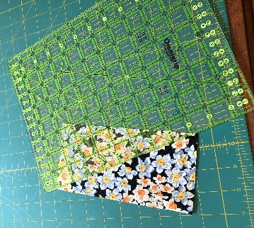

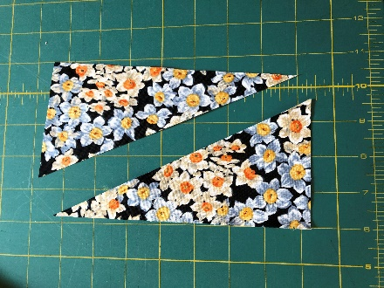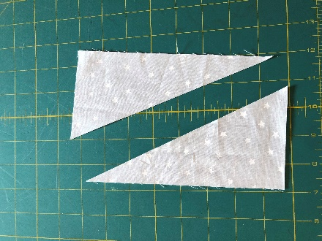

When you are done, you will have a total of the following quantities of triangles.

 | Baby Quilt | Lap Quilt
Fabric A Triangles | 20 | 36 (one extra 😊)
Fabric B Triangles | 20 | 36 (one extra 😊)

Step 4 – Sew your triangles together to make block AB1

Take an A and a B triangle and pin them right sides together along the hypotenuse line of the triangle, with the points overhanging the edge as shown. Pin each A/B pair together as shown.

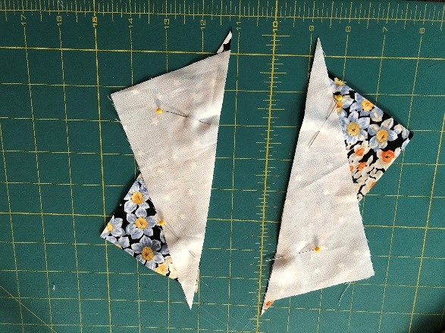

Sew each pair together, using a ¼” seam. Press open and voila! You have completed Triangle AB1 and are ready for next month! Where you will be making the AB2 triangle blocks — the mirror image of this block.

Making Triangles with Paper Piecing

You know this about us already, but we are mad about paper piecing! It’s a bit more time-consuming but you can’t beat paper-piecing for precision.

Diana made a video of the paper-piecing technique that we are using. This is the link to the video on youtube: https://youtu.be/WMTGZe7T2Fk

We’ll also go over this again on the October 27 Mystery quilt Zoom call so there will be multiple opportunities to review the technique. If it’s possible for you to join the 10/27 in your sewing space, you can work along with Diana as she demoes the technique.

It might seem a little complicated the first couple of blocks that you do but after 3 or 4, it will start feeling very natural. So give yourself a little time.

Step 1 – Cut your fabric strips

As mentioned above, the strips used in paper piecing are narrower than those used in strip piecing the AB triangle blocks. You can use the 3-5/8” strips for paper-piecing but you can’t use the 3.5” strips for the strip-pieced triangles.

If you are not ready to commit to paper-piecing all of your triangles but want to try it out, JUST CUT ONE STRIP EACH OF FABRICS A & B 3.5” x WOF. It’s really okay to be ambivalent about this!

Depending on the amount of fabric waste between cuts, you may end up with between 6 and 8 AB1 triangle blocks from each pair of A & B fabric strips. This is another reason to wait to cut your fabric until you are comfortable with the technique.

So let’s start with 1 strip each of Fabric A and Fabric B 3.5” x WOF and perfect the technique. When you are ready to cut the rest of the strips, these are the approximate quantities needed.

Strips needed for paper-pieced AB1 triangles – when you are ready to commit to paper-piecing – THESE WILL BE TOO NARROW TO USE IN STRIP PIECING!

 | Baby Quilt | Lap Quilt
Cut 3.5” strips WOF Fabric A | 3 (maybe 4) | 5 (maybe 6)
Cut 3.5” strips WOF Fabric B | 3 (maybe 4) | 5 (maybe 6)

Step 2 – Ready your paper piecing templates

Attached is a separate document with the paper piecing template blocks for Triangle Block AB1. There are 2 triangle paper piecing patterns on each sheet. You will need to print out enough paper piecing sheets to make 20 AB1s for the Baby Quilt, or 35 AB1s for the Lap Quilt.

 | Baby Quilt | Lap Quilt
Completed Triangle AB1 | 20  (print out 10 AB1 paper piecing sheets) | 35  (print out 18 AB1 paper piecing sheets)

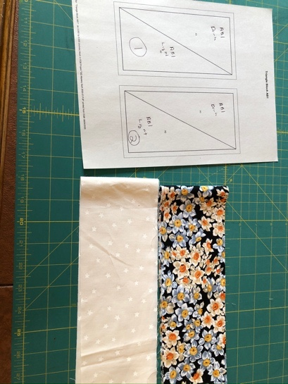
Print one sheet out and check your measurements. The unfinished paper-pieced blocks will be 3.5”x 6.5”. If it does not print to that size, make sure your printer is set to print to Actual Size. You can print onto regular printer paper or special paper-piecing paper. If you are having difficulty, let us know and we can provide printouts.

Cut out the AB1 paper-piecing templates along the dotted outer lines. You will have 2 AB1 blocks from each sheet of paper.

Fold the AB1 paper-piecing template (right sides together) along the diagonal line (the hypotenuse of the triangle) between the dark and light. Keep it folded for now.

Step 3: Make your first AB1 triangle block

Take 1 strip of A (dark) fabric and B (light) fabric and place them right sides together. Match 1 set of seams. Lay the strips flat onto your work table with the A (dark) fabric facing up.

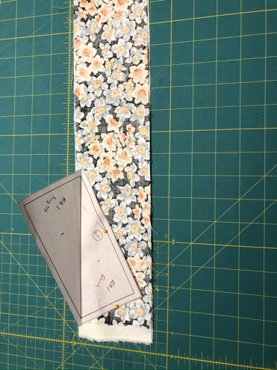
Now take the first folded paper-piecing template and place it on top of the A-B paired strips with A-side of the template facing the A (top) fabric and the folded edge about ¼” from the seam. Open the paper fold and pin the template and fabric in place.

Bring the strips to your sewing machine. You’ll want to use a smaller stitch length when paper piecing to make it easier to remove the paper later. Sew along the dark hypotenuse line.

Cut the thread and remove the fabric and template from your sewing machine. Open the fabric and template, remove the pins, and take it to your ironing board. Iron the seams open.

Place the ironed strips onto your cutting board with the paper side facing up.

The next part of the cutting technique is REALLY IMPORTANT!!

Using your rotary cutter and ruler, cut around the outer border of the block. Stop cutting at each corner so that you are leaving dangling end triangles connected to the remaining strips of fabric. DON’T CUT ALL THE WAY TO THE END OF THE FABRIC as you will need it for the next block.

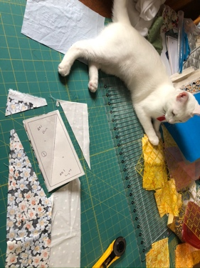
Voila! You’ve made your first AB1 triangle block!

Step 4: Time to Make your second AB1 triangle block

This is the step where you learn to use fabric for paper piecing very efficiently!

Take the second AB1 triangle block template and fold it in half with right sides together along the hypotenuse.

Then take the 2 strips of A & B fabrics, still with right sides together, and using the dangling triangle ends where you were just cutting.

Then place the folded paper piecing template onto the A-B strip with about a ¼ inch seam allowance along the edge. Open the paper and pin in place. You can see in the photo below that I’ve matched the edge of the block right along the cut edge from the first AB1 triangle.

Remember to match the top fabric to the corresponding paper piecing side (so if the dark-A fabric is on top, you will want the template facing it to be the dark side as well).

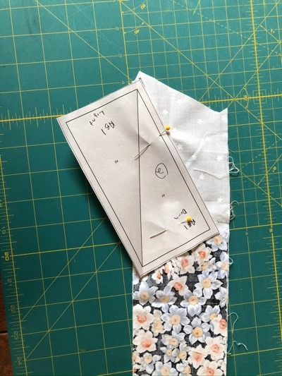
Pin the paper to the fabric Take the folded AB1 triangle block and place it on top of the A-B fabric pair with the ends as close to the edge of the fabric as you can. Pin in place and take to your sewing machine. Sew along the hypotenuse line.

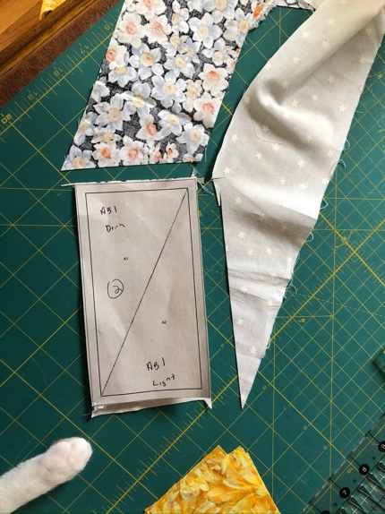
Press this open and again cut around the outside edge of the block.

Step 4: Continue making AB1 triangle blocks

Again, take your A & B fabric strips and place them right sides together, continuing to use the dangling end and matching as close as possible to the cut edge of the previous AB1 block.

You should be able to get about 6 to 8 AB1 triangle blocks from each strip pair. After you have used up the fabric in the first pair of strips, you’ll have a sense of how many pairs of fabric strips you will need for the project.

And Finally…….

Next month we will be working on the Triangle AB2 block – which is a mirror image of AB1. Now that you have mastered AB1, this will be much easier.

Note also that the following month will be a less time-consuming step than these triangles, so if you can’t finish them all, don’t worry that you will fall behind. You’ll have time in January to finish the AB1 and AB2 triangle blocks as well as the next step in the process!

Happy quilting and please let us know if you have questions!

